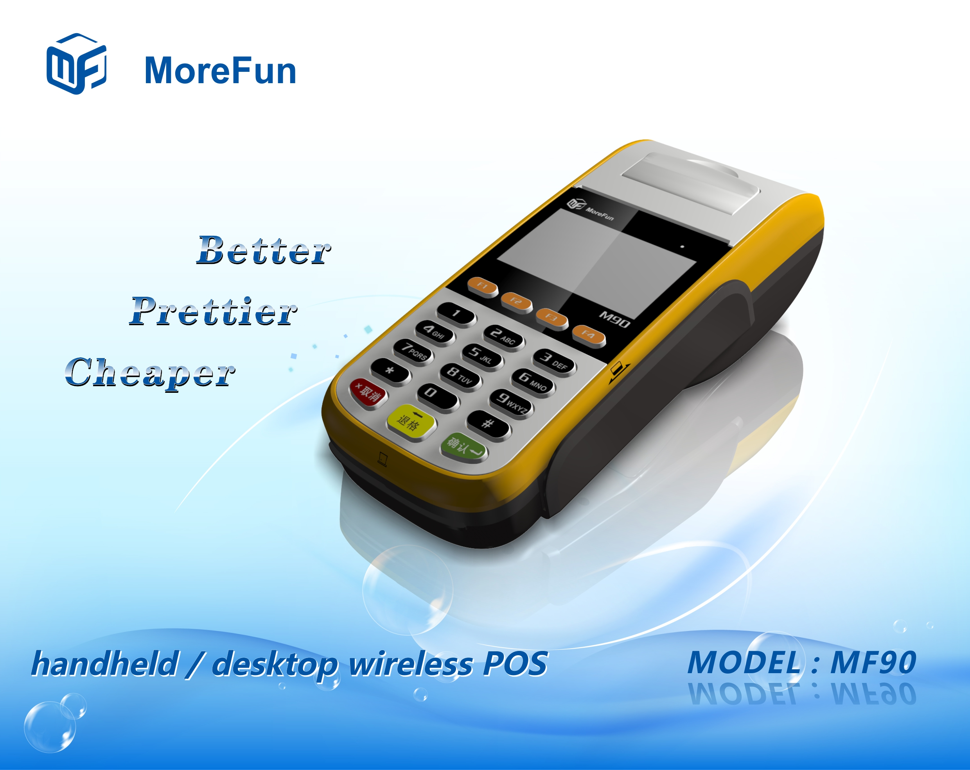

Product description:
MF90 is a new generation of desktop / handheld wireless payment terminals developed by Fujian MoreFun Electronic Technology Co., Ltd. based on the experience accumulated in the field of traditional financial equipment and users' good feedback. The product has streamlined appearance design, meet all kinds of business needs of the existing handheld mobile terminal, also with high cost-effective, to be used as a desktop terminal, with a portable appearance and superior battery life, it is the preferred equipment for financial handheld payment, mobile payment, logistics and distribution, home payment, data collection and so on.
Product features:
- 320*240 Color LCD
- Compact and fashion appearance, superior performance, fast response at starting up and interactive operation.
- Built-in large capacity battery, work continuously for long time, support more transactions.

- Optional support 1D / 2D barcode reading function, meet the demand of scanning code payment.
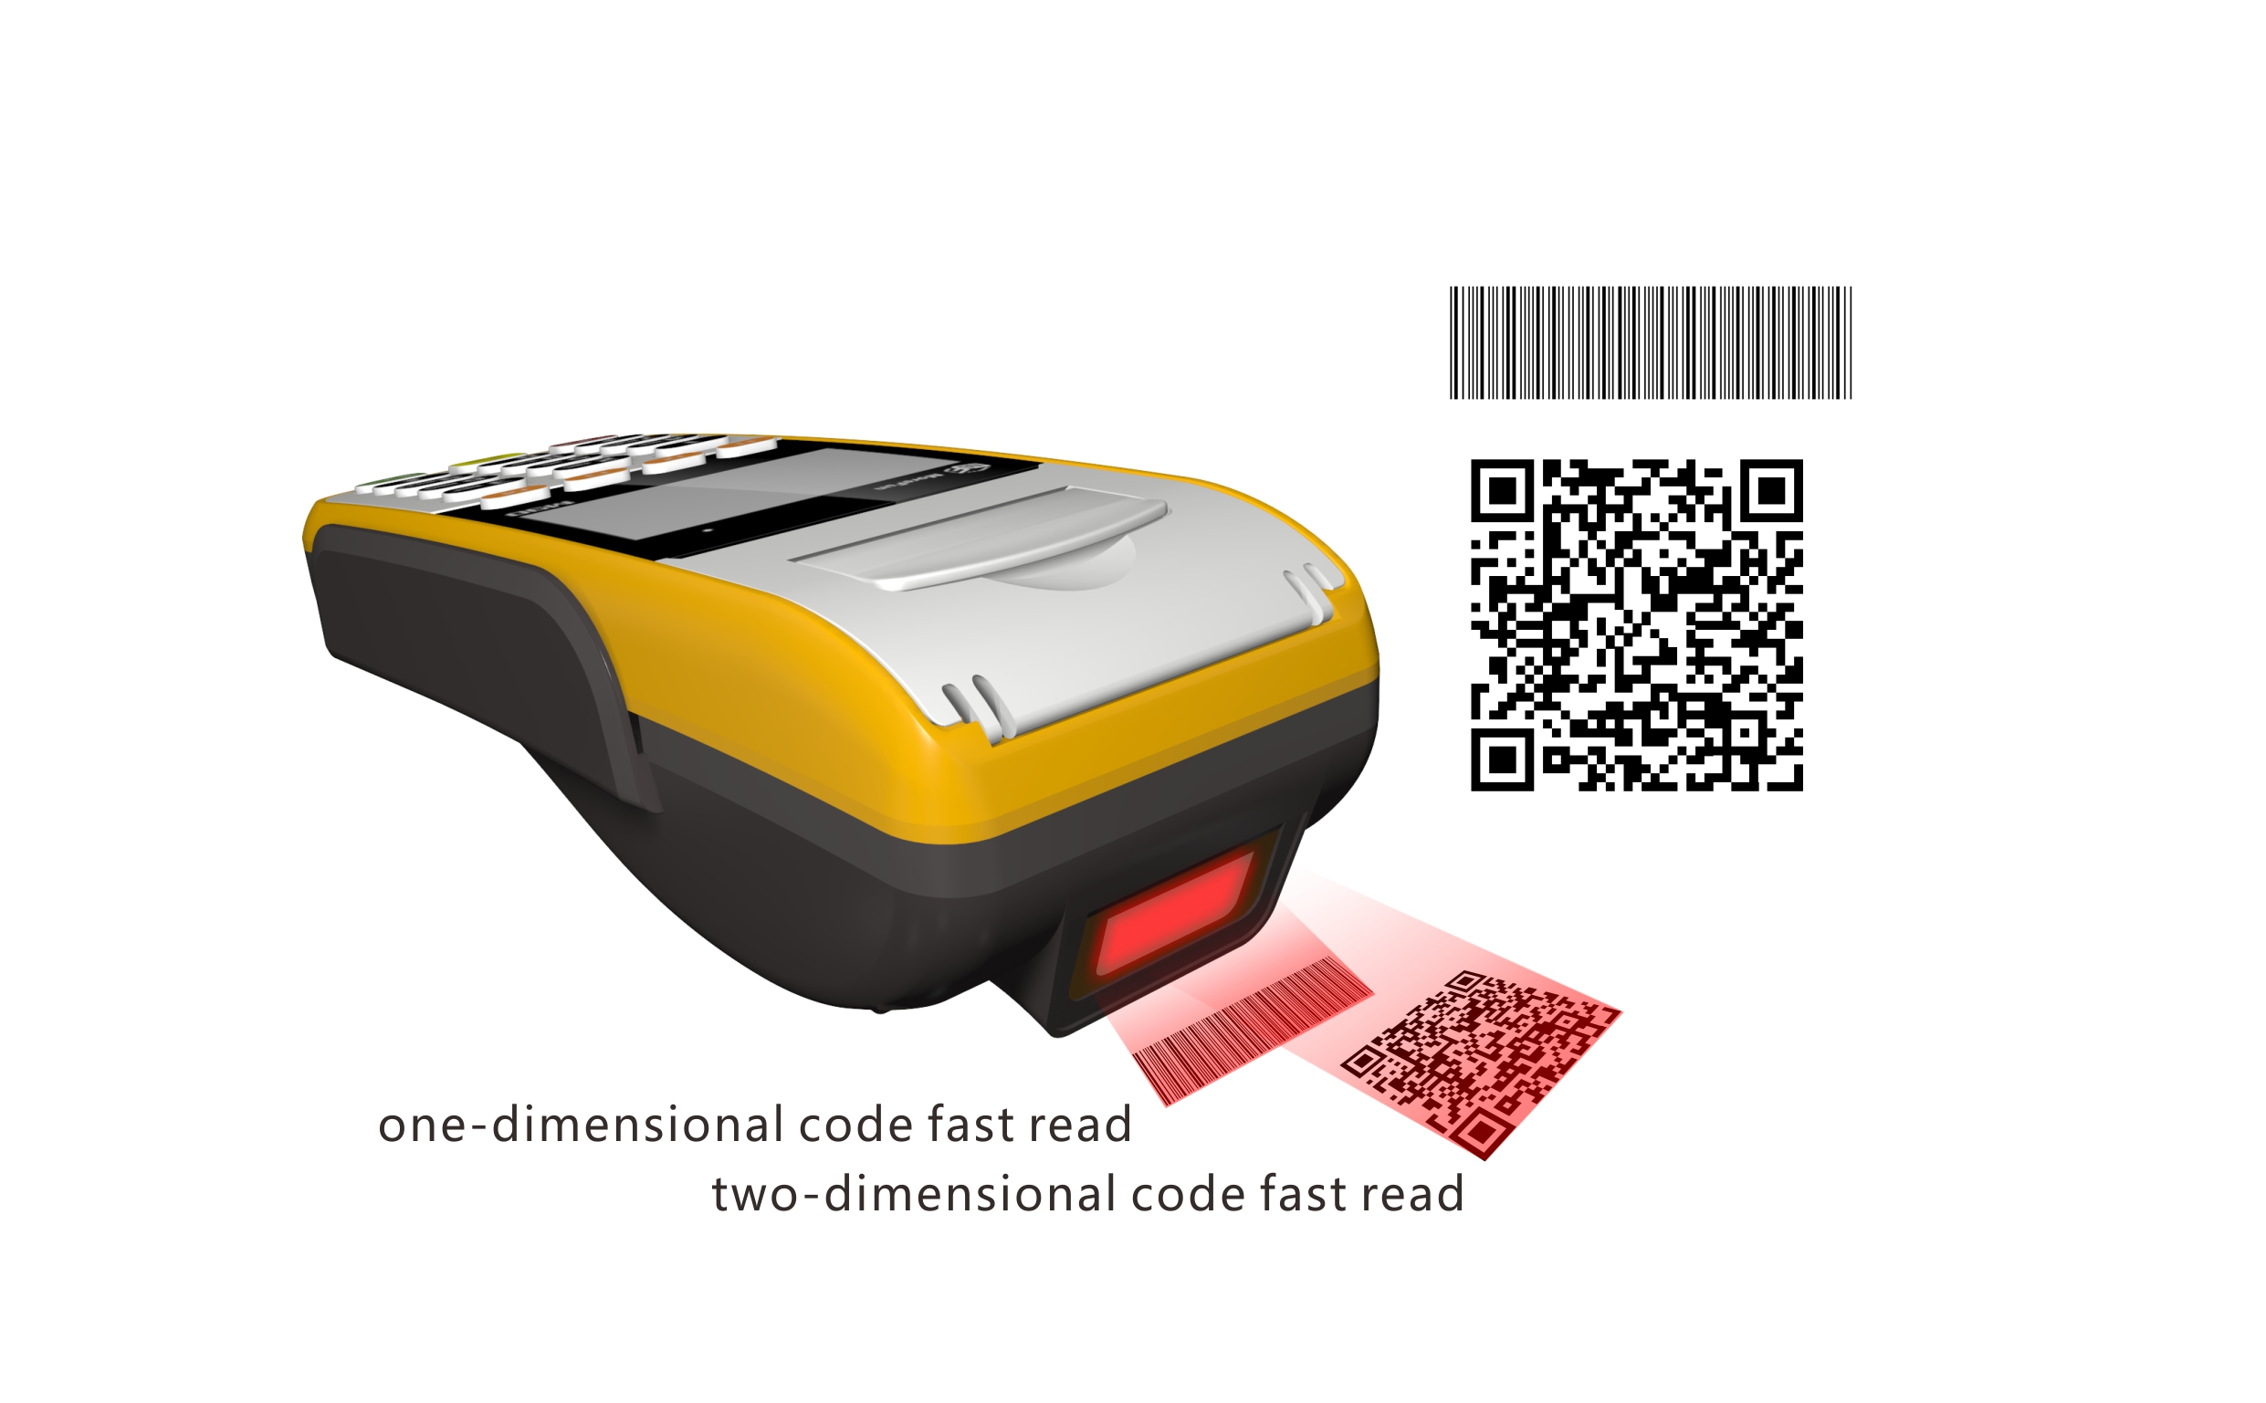

Product specification:
Processor | - High performance 32-bit security processor
Memory | - 8MB (64Mbit) Large capacity memory
Display screen | - 320*240 Color LCD, with backlight
Keyboard | - 0~9 number key, *, #, confirm, cancel, delete, ect, total 19 keys
Magnetic card reader | - Support 1/2/3 magnetic track bi-directional reading  - Can support high coercivity magnetic card reading  - Can support ISO 7810、ISO7811-1,2,3,4,5,6、ISO7813 standard magnetic card reading  - Can support 0.1m/s～1m/s swiping card speed
IC card reader | - One user card base  - Support 3V or 5V card  - Support ISO7816CPU card, comform to PBOC and EMV standard
Contactless card reader (optional) | - 13.56MHZ，support type A/B, mifare one card
SAM card reader | - One pcs, conform to ISO7816 standard
Password keyboard | - Password keyboard built-in  - Conform to ANSI X9.8/ISO9564, ANSI X9.9/ISO8731 standard  - Support DES, 3DES, RSA, SHA-256 algorithm  - Support MK/SK
Communication method | - GPRS
Printer | - Built-in high speed thermal sensitive printer, support graphic printing, wide 58mm, scroll diameter 40mm
Barcode reader (optional) | - Built-in 1D/2D barcode reader
Physical interface | - 1pcs RS232
Battery | - Built-in rechargeable lithium battery: 7.4V 2600mAH
Size | - 186.5 mm X 80.6 mm X 52.3mm
Certification | - CCC cert, Telecom access cert.  - EMV/PBOC 3.0 level1 & level2 cert.  - PBOC 3.0 non-contact level1 & level2 cert.  - PIN input device security certification  - UnionPay direct connect POS application test  - UnionPay network cert.

